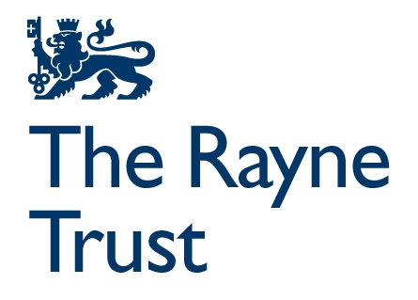
Where People Meet Grant Programme
Expression of Interest Form
Applicant Information
1. Organisation Details
- Organisation Name:
- Website:
- Address:
- Legal entity and Registered Number:
- Contact Name:
- Position/Role:
- Email:
- Phone Number:

2. Organisation Overview
Provide a brief description of your organisation’s purpose, history, and key activities (maximum 150 words)

Project Information
3. Project Title
- Proposed Project Title:

4. Project Summary
Provide a summary of your project, including the proposed works, activities and intended outcomes, referring to the funding priorities listed in Appendix A (maximum 1500 words)

5. Project Location
- Address or location of the building where work will take place:

6. Ownership and protection
Explain who owns the building and what protections are in place (e.g. asset locks) for its community use into the future. If a lease hold, how long is the lease term?

7. Project Timeline
- Proposed start date:
- Anticipated completion date (must be by March 2028):

8. Funding Details
Total Project Budget
- Estimated total project cost: £
- Amount requested from the Where People Meet Grant Programme: £

Match Funding
Provide details of any confirmed or anticipated match funding for this project:

9. Supporting Documents
Please attach the following required information:
- A project budget breakdown.
- Evidence of building ownership or a lease agreement with at least 25 years remaining.
- Most recently audited accounts.

Please attach any other relevant documentation in support of your application (these are optional):
- Letters of support from local stakeholders or partners.
- Any other existing documents that support your application, for example architectural plans, project plan etc.

Privacy Statement
The Rayne Charities are committed to protecting your data and privacy in accordance with the provisions of the Data Protection Act 1998 and the General Data Protection Regulation (GDPR) 2018. Our privacy notice tells you what to expect when we collect your personal information. It tells you how we will use the information and the rights you have in relation to this. To read our privacy notice, please visit our website: http://www.raynefoundation.org.uk/privacy-notice.

Declaration
I confirm that the information provided in this Expression of Interest is accurate to the best of my knowledge and that the proposed project meets the criteria of the Where People Meet Grant Programme.
Name: _____________________________________
Position: ___________________________________
Signature: _________________________________
Date: _______________________

Submission Instructions
- Completed Expression of Interest forms must be submitted via email to wpmprogramme@raynefoundation.org.uk by 12 noon 6 October 2025
- For any questions or further information, please contact wpmprogramme@raynefoundation.org.uk

Appendix A
In assessing the EOIs, priority will be given to the following criteria:
How local leadership is developed
- Potential for wider application and influence - in all the work we fund, we look for organisations and projects that are doing things differently from which others can learn and that have lessons beyond the local. Those individuals and organisations leading the project will be engaged and influencing policy and commissioning to improve financial flows to community spaces or have clear ambition to do so.
- Local leadership and accountability - the project is driven and led by local people and organisations at all stages and creates opportunities for a broader group of local people to influence and make decisions.
- Partnership - partnership working is embedded in the design and delivery of the project, and health, civil society, local businesses, statutory and other relevant partners are actively engaged in delivery where appropriate.
How local people benefit
- Inclusive - the primary purpose of the project is to create and/or enhance a multi-use physical community space to deliver positive benefits to the widest range of people in the community, including those that experience the most disadvantage and marginalisation.
- Wellbeing - the wellbeing of local people is at the heart of the the work and projects are preventative in a way that averts crises and gets to problems before they take over people's lives.
- Quality - projects are working to create community spaces that are well-designed, accessible to all, welcoming and warm, and maximising the potential of inside and outside environments, creating with local people a place they feel they belong.
How projects are sustained
- Deliverable - the project will have already developed a clear approach to planning, resource and delivery. Funding from the Trust will enhance and amplify existing work and the project will be delivered within an 18–24-month timeframe.
- Sustainable - projects will demonstrate progress towards environmental sustainability and have secured or are able to lever additional funding to support and sustain activities.

