“Where People Meet” Pathfinder Project Case Study

Where People Meet is an experimental pilot grants programme. Through grants to community spaces, we aim to raise the profile of community led regeneration and shine a light on new solutions to challenges faced in our communities. We are therefore looking to fund projects and initiatives which are out of the ordinary and challenge the status quo.

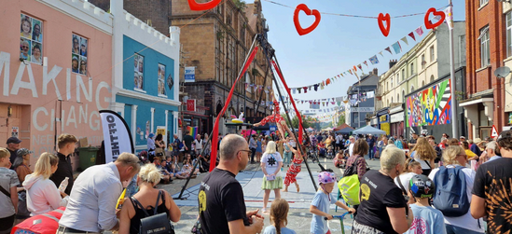

Pathfinder Spotlight: Nudge Community Builders

Earlier this year the Trust awarded a £250,000 pathfinder grant to Nudge Community Builders, based in Stonehouse, Plymouth.

Nudge demonstrates what genuine community-led regeneration can look like; where local people lead, buildings are transformed, small organisations are nurtured, and spaces become places of belonging and creativity.

Nudge formed in response to the impact of long-term empty buildings falling into disrepair on the Union Street in Plymouth. “[Some of these buildings] hold memories for thousands of people and it’s been deeply sad to see them falling into disrepair.” Hannah Sloggett, Co-Director, Nudge Community Builders.

Over the last 10 years, Nudge have unlocked 25% of the empty buildings along Union Street, reclaiming them for community use as spaces to incubate local businesses, host events and bring people together.

What Makes Nudge a Model Project?

Power in local hands: Nudge is a Community Benefit Society, meaning its governance and operations are shaped by people who live in the area. Projects are conceived, designed and managed by local people. Nudge incubates local grassroots organisations, fostering leadership from within the community rather than imposing external agendas. Hannah, the co-director describes that how they do things is as important as getting the job done:

“We work at a pace that enables local people to come and see what is happening
and can adjust and respond as we see what has impact. This is essential because it
enables us to repurpose materials on site in creative ways, it saves us money when
volunteers can pick up time consuming or bespoke elements of a project, and we
know embedding this love and care through the development process creates a long
term sense of local ownership and lasting sense of hope in our community.”

Transforming derelict buildings: The grant supports the revitalisation of a formerly derelict property at C103 on Union Street, turning it into a vibrant centre for community gathering, social enterprise, and indoor farming. This echoes best practice in community‑led design and reuse, marrying respect for local history with present‑day needs.

“The thing we hear most is that the physical changes we are making give people
hope. It also represents opportunity - space to connect with diverse communities,
create jobs, volunteering roles and opportunities for other community organisations
to scale their impact.”

Honouring local heritage while birthing new uses: Nudge preserves the architectural memory of the street and neighbourhood, while reimagining its use to serve current residents, bringing colour, energy, and purpose back into a neglected corner of Plymouth.

“It offers an opportunity for our community to show how a different way of working can provide support for some of the most challenging issues experienced in our neighbourhood with a particular focus around health, wellbeing and social isolation.”

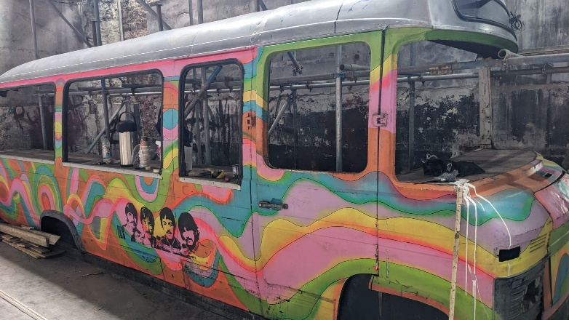
The C103 building was most recently a nightclub. Nudge have stripped the building back, looking after heritage features and retaining things that mean a lot to local people like the dance floor and an old bus that was used as a bar.

Long‑term sustainability: Nudge have secured investment from multiple sources and work dynamically, developing parts of the building and hosting events as the building develops rather than waiting to secure everything before starting. 595 people have invested in community shares in Nudge. Community shares are a way of people coming together and using their money to make something happen that they care about.

..................

The Where People Meet open call invites applications from community leaders and organisations working to create or enhance community spaces that are inclusive, adaptable and built from the ground up.

To be eligible for the funding, you don't have to build something from the ground up like Nudge. The essence of the dynamism and challenging the status quo will look different in every community but out of the ordinary approaches to developing community spaces is what we’re really interested in.

For teams creating or enhancing local community spaces that put local people in charge, revive local heritage, and build shared spaces of hope, this is your moment.

For more information on the criteria and to apply, follow this link: Where People Meet Grant Programme - Rayne Foundation

